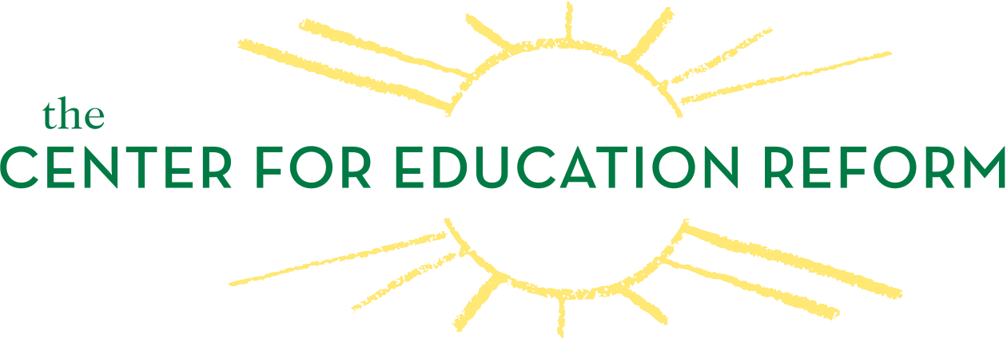

The State of Charter Schools
What We Know – and What We Do Not – About Performance and Accountability

National Press Club, Murrow Room
529 14th Street NW, 13th Floor, Washington, DC 20045
December 21, 2011
10:30 a.m. – 11:30 a.m. EST

Agenda

Introduction

Jeanne Allen, President, The Center for Education Reform

Key Findings from the Report

Alison Consoletti, Vice President of Research, The Center for Education Reform

Discussants

Brian W. Jones, Chairman, District of Columbia Public Charter School Board

Mary Kay Shields, Interim Executive Director, The Center for Charter Schools, Central Michigan University

Ursula Wright, Interim President and CEO, National Alliance for Public Charter Schools

Q&A

Moderated by Jeanne Allen, President, The Center for Education Reform

